Types of Action Verbs
# Source: AI Source: Provided by: [Data Path: Persons Table -> ID Column: 1, Name_En Column: Motasem Essam] -> From: [Chatgpt (GPT-4-turbo)] on [7/27/2025]
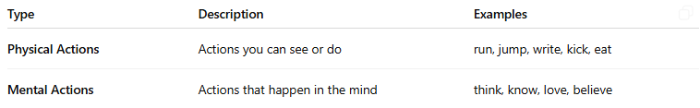
Type | Description | Examples
Physical Actions | Actions you can see or do | run, jump, write, kick, eat
Mental Actions | Actions that happen in the mind | think, know, love, believe

